A.Sahith TASK3

Approach:

Here I have used SQL for analysis, PostgreSQL is the tool which I have used for analysis

Case Study 1

1. **Jobs Reviewed Over Time:**

* Objective: Calculate the number of jobs reviewed per hour for each day in November 2020.
* Your Task: Write an SQL query to calculate the number of jobs reviewed per hour for each day in November 2020.

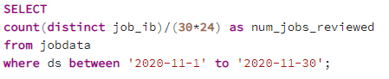

1. **Throughput Analysis:**

* Objective: Calculate the 7-day rolling average of throughput (number of events per second).
* Your Task: Write an SQL query to calculate the 7-day rolling average of throughput. Additionally, explain whether you prefer using the daily metric or the 7-day rolling average for throughput, and why.

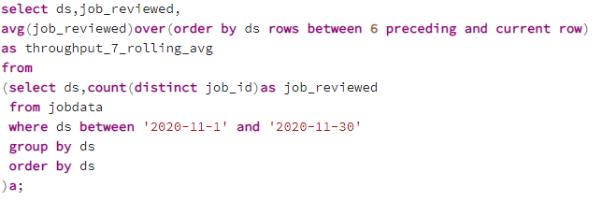

1. **Language Share Analysis:**

* Objective: Calculate the percentage share of each language in the last 30 days.
* Your Task: Write an SQL query to calculate the percentage share of each language over the last 30 days.

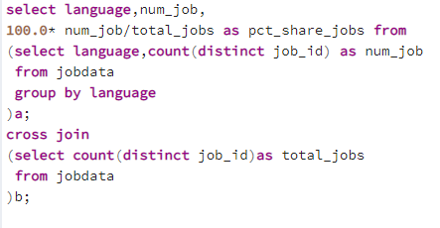

1. **Duplicate Rows Detection:**

* Objective: Identify duplicate rows in the data.
* Your Task: Write an SQL query to display duplicate rows from the job_data table.

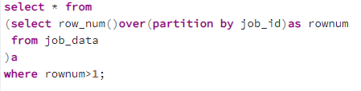

Case study2

1. **Weekly User Engagement:**

* Objective: Measure the activeness of users on a weekly basis.
* Your Task: Write an SQL query to calculate the weekly user engagement.

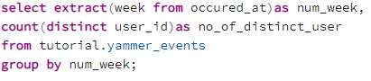

1. **User Growth Analysis:**

* Objective: Analyze the growth of users over time for a product.
* Your Task: Write an SQL query to calculate the user growth for the product.

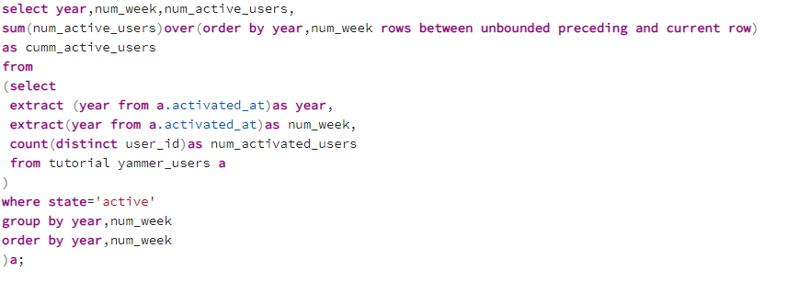

1. **Weekly Retention Analysis:**

* Objective: Analyze the retention of users on a weekly basis after signing up for a product.
* Your Task: Write an SQL query to calculate the weekly retention of users based on their sign-up cohort.

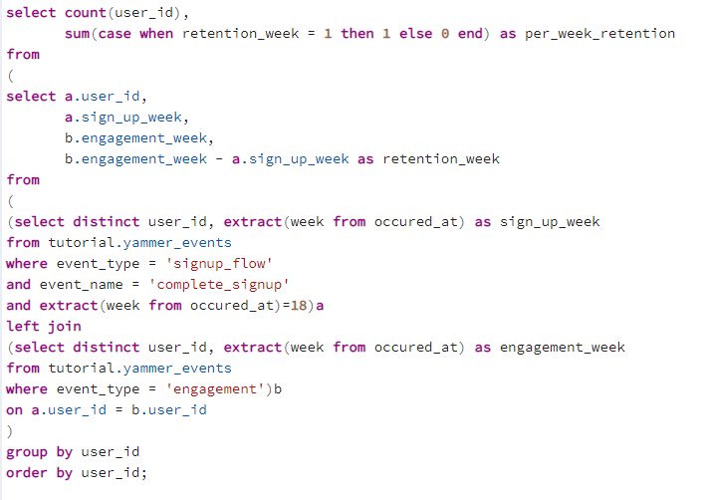

1. **Weekly Engagement Per Device:**

* Objective: Measure the activeness of users on a weekly basis per device.
* Your Task: Write an SQL query to calculate the weekly engagement per device.

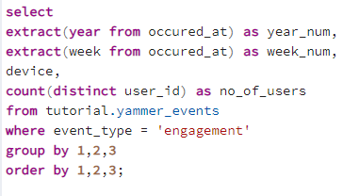

1. **Email Engagement Analysis:**

* Objective: Analyze how users are engaging with the email service.
* Your Task: Write an SQL query to calculate the email engagement metrics.

